Template for Evidence(s)
UI GreenMetric Questionnaire

University : ...
Country : ...
Web Address : …

[1] Setting and Infrastructure (SI)
SAMPLE
[1.4] Campus Setting

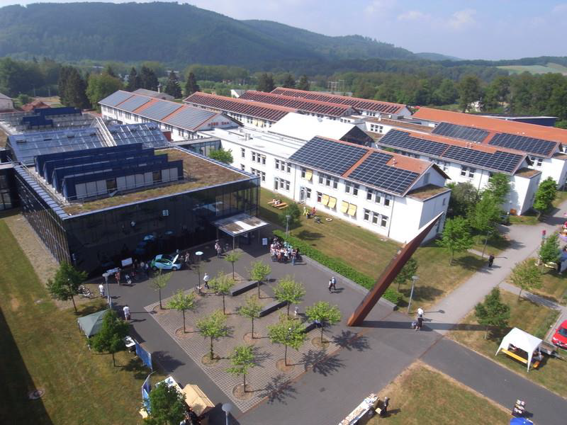
Example of Campus Setting - Rural (Umwelt-Campus Birkenfeld, Germany)

Description:
(Please describe your campus setting. The following is an example of the description. You can describe more related items if needed.)

Environmental Campus Birkenfeld (ECB) is located in a rural area with a high rate of forest cover. ECB belongs to the district Birkenfeld which is located in the southern part of the state of Rhineland-Palatinate. The district Birkenfeld has a total area of 777 km² and a total population of 80,728. This means a low population density of 104 inhabitants per km².

Additional evidence link (i.e., for videos, more images, or other files that are not included in this file):

